School Supply Lists

**Instructions:**

**Convert** your supply list to PDF

**Go** **to** <http://docushare.everett.k12.wa.us/docushare/dsweb/View/Collection-117>

**Log in** with your district network username and password.

**Open** your school’s collection

**If there is a supply list:**

**Click** on the three dots to the right   


**Click** Upload a New Version

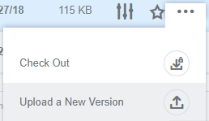

**Upload** the new supply list

**Click** *Apply*

If you have any questions contact LauriBeth Hull at [lhull@everettsd.org](mailto:lhull@everettsd.org) or 425-385-4208